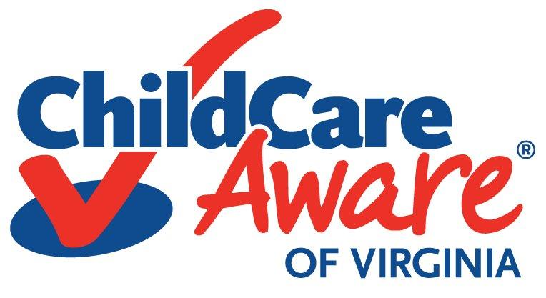
We Need Your Help!!

Parent Voices Make a Difference!!

The Virginia State Legislature is currently meeting in Richmond, but only for a short period of time. We need your help to make sure that our state policymakers know that working parents depend on quality child care! And, that support for quality child care should be a priority for state legislators this year!

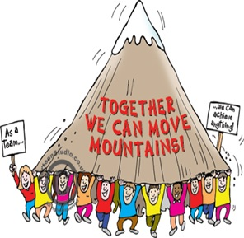
Volume matters. State legislators need to hear from all of us! There are many bills pending before the State legislature and many high paid interests who are lobbying for their issues. We need to make sure that legislators hear from working parents about the importance of investing in child care.

The Bottom line: Throughout Virginia, more than 393,000 children under the age of 6 have working parents. Parents need a safe place for their children to be while they work – a place that also promotes the healthy development of their children so that they start school ready to learn.

What State Legislators Need to Hear: For young children in Virginia, child care is an early learning program. But, parents have trouble affording it. And, state rates paid to child care providers are far below market costs. For quality care, it is critical that state legislators both invest in strengthening the child care workforce and provide programs with rates that support quality operations. Licensed, high quality child care is the foundation for early childhood development. Working parents depend on it!

Taking Action is Easy!!

We have a new Take Action web site that offers parents, grandparents, and everyone concerned about quality child care an easy way to reach their state legislators. An email to state policymakers is already written, all you have to do is type in your name, address, and email so that you can send a note to your legislators. If you want to edit the message, you can. Or, if you want to just send it “as is,” that’s fine too. What matters most is that EVERYONE uses the take action center so that our voices are heard in Richmond. Click here to use our action center. Or, cut & paste the following URL to your browser to reach the page http://bit.ly/WbLcjF.

We need everyone’s voices to be heard. Every email counts. Please take action today!

